Introduction:

Autonomous driving is a rapidly advancing field of research that has the potential to revolutionize transportation. One of the critical challenges in this area is detecting and classifying traffic signs in natural street scenes. In recent years, the YOLO (You Only Look Once) architecture has emerged as a promising approach for object detection, including traffic sign detection. YOLO v8, the latest version of the YOLO architecture, has shown remarkable performance in this area. In this paper, we present a YOLO-based approach for traffic sign detection using YOLO v8 and propose a novel modified loss function to improve its performance. Our results demonstrate the effectiveness and efficiency of our approach, paving the way for improved autonomous driving systems.

Related work

Autonomous driving is a fascinating area of research in modern times, and detecting traffic signs is a crucial and essential problem in this field. This project aims to investigate the effectiveness of the YOLO architecture in solving this problem. The goal is to locate and classify traffic signs in natural street scenes. One of the key challenges of this problem is identifying small targets in a complex and extended image background. Although other object detection models such as Fast RCNN and Faster R-CNN have been used for this purpose, they are slow and not real-time. Therefore, we explore YOLO, which is about 6 times faster than Faster R-CNN, for this task. Additionally, we propose a novel modified loss function for the YOLO model to improve its performance in traffic sign detection.[1]

Dataset​

Link: <https://www.kaggle.com/datasets/valentynsichkar/traffic-signs-dataset-in-yolo-format>​

Number of samples:741​

Number of training data: 630​

Number of test data: 111 ​

Classes number: 4​

Classes labels: [“prohibitory” , ” danger” ,  “mandatory” , ” other”]​

The dimension of images: 640*640 with 3 channels

Methods

We used YOLOv8 medium.  YOLOv8 is the latest and most advanced iteration of the highly popular real-time object detection system. It has undergone continuous improvements and refinements to deliver exceptional performance in terms of speed, accuracy, and efficiency. With a focus on pushing the boundaries of real-time object detection, YOLOv8 introduces several groundbreaking advancements that make it a top contender in the field of computer vision. Here are some of the most notable features of YOLOv8 [**Enhanced Backbone Network, Advanced Data Augmentation Techniques, Multi-Scale Feature Fusion, Optimized Anchor Boxes, Efficient Model Pruning, Improved Training Techniques, Real-Time Inference on Edge Devices**]

In our model, we have used YOLOv8m (medium), we trained model using ‘Traffic Signs Dataset in YOLO format’ dataset that contains 4-class with 630 images for Train and 111 images for Validation. The model contains 25858636 parameters and 295 layers. We trained the model for 30 epochs.

**Result of training**

**Confusion matrix**

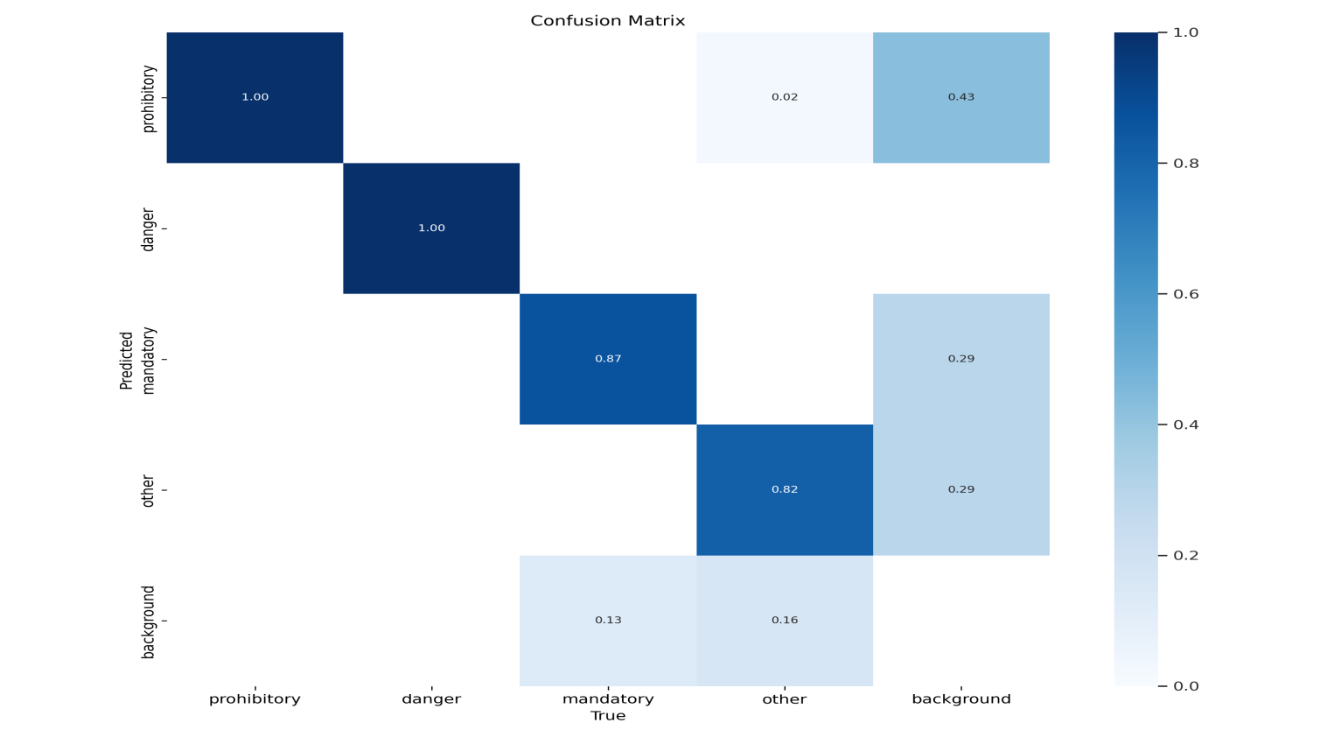

**F1 score**

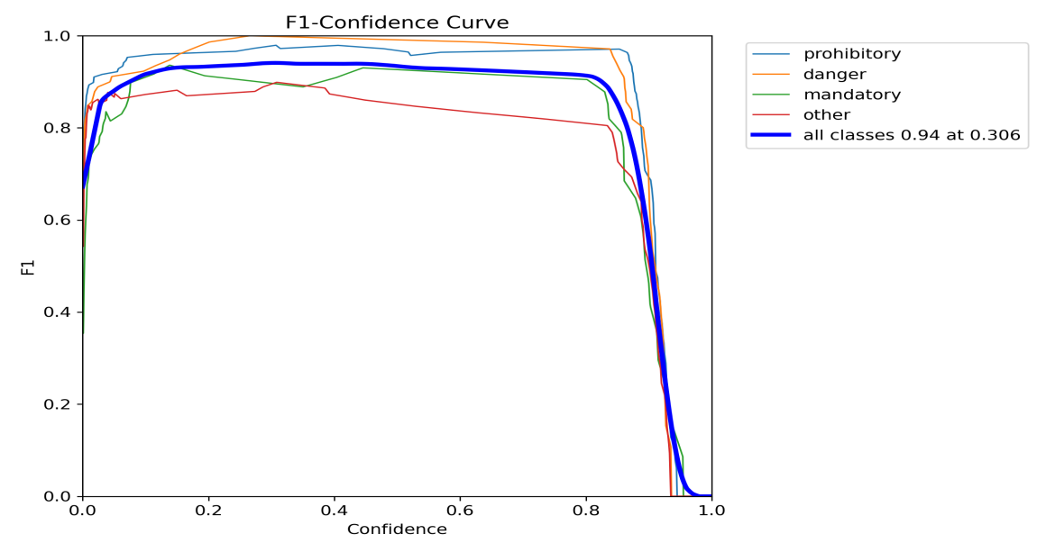

**Precision Curve**

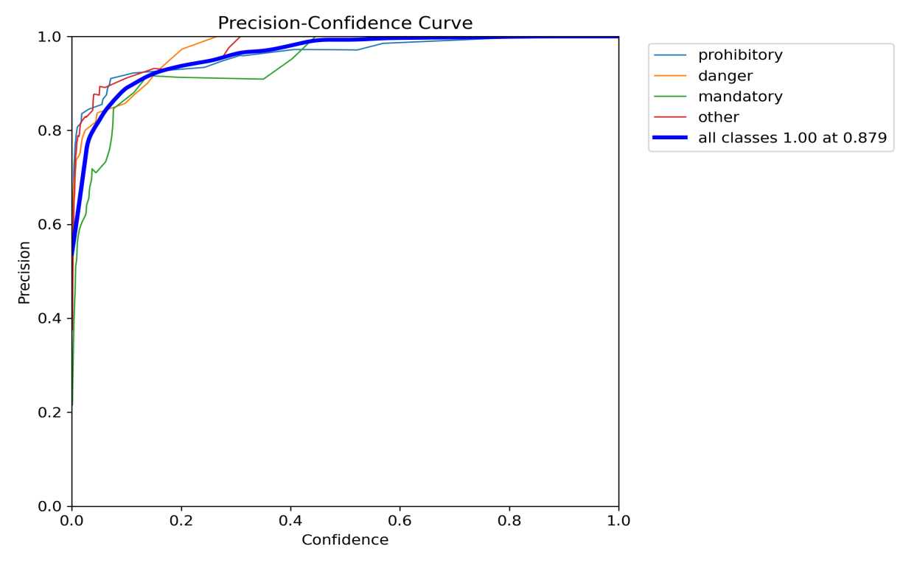

**Recall curve**

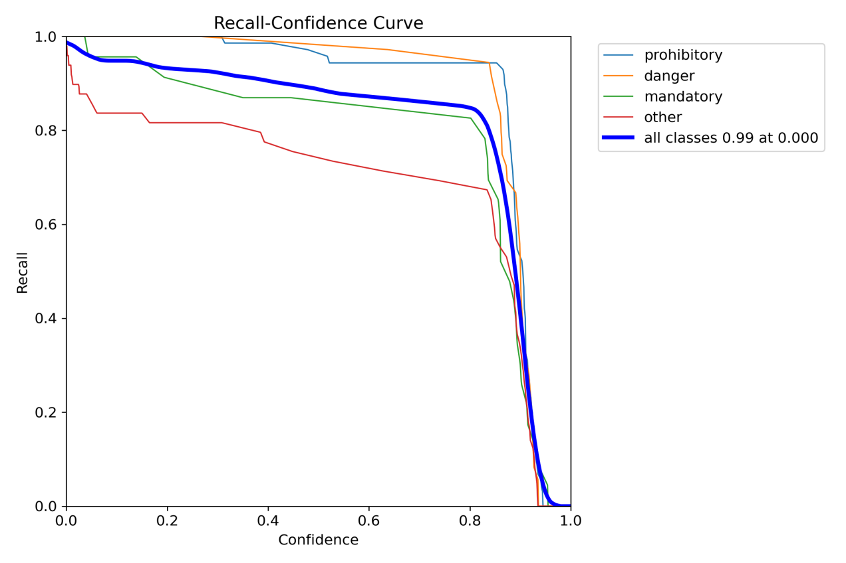

**Result of validation**

**Confusion matrix**



**F1 score**



**Precision Curve**



**Recall curve**



**Reference**

1. **M. 15it217, Vikram, and P. Ananthanarayana. "A YOLO Based Approach for Traffic Sign Detection." 15IT217 M M Vikram, 2021. Available: https://vikram-mm.github.io/yolo_report.pdf.**